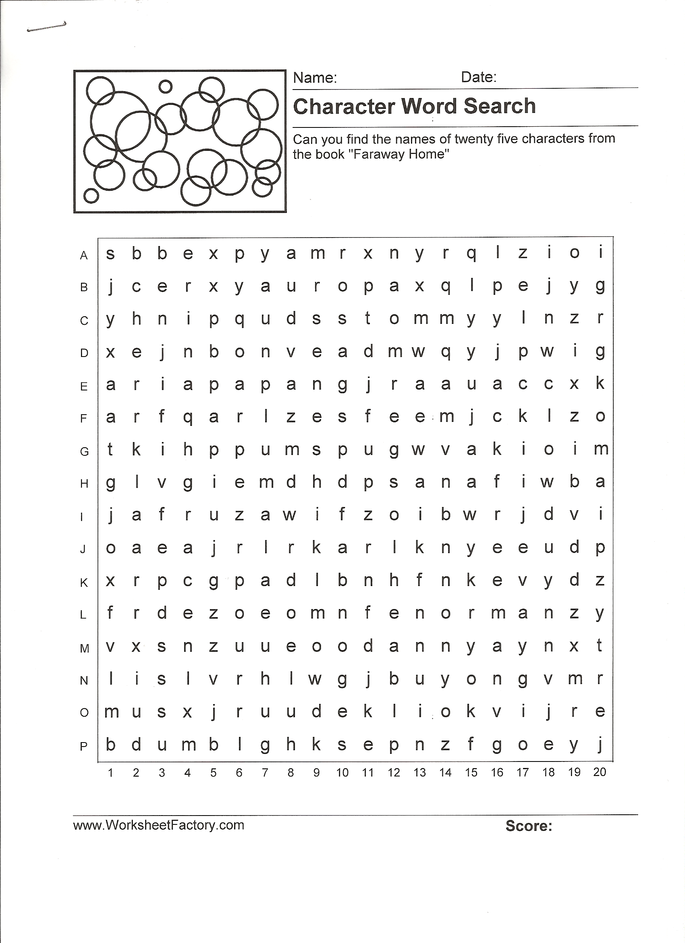
Faraway Home

Find The Following Characters
In the Wordsearch

- Lisl
- Danny
- Norman
- Karl
- Papa
- Tommy
- Herr Klaar
- Benji
- Rina
- Mr. Senesh
- Rosa
- Oma
- Jack Freeman
- Leni
- Yakobi
- Judy
- Gaby
- Susi
- Rudi
- Pearl
- Grace
- Goulds
- Peewee
- Eva
- Mama

