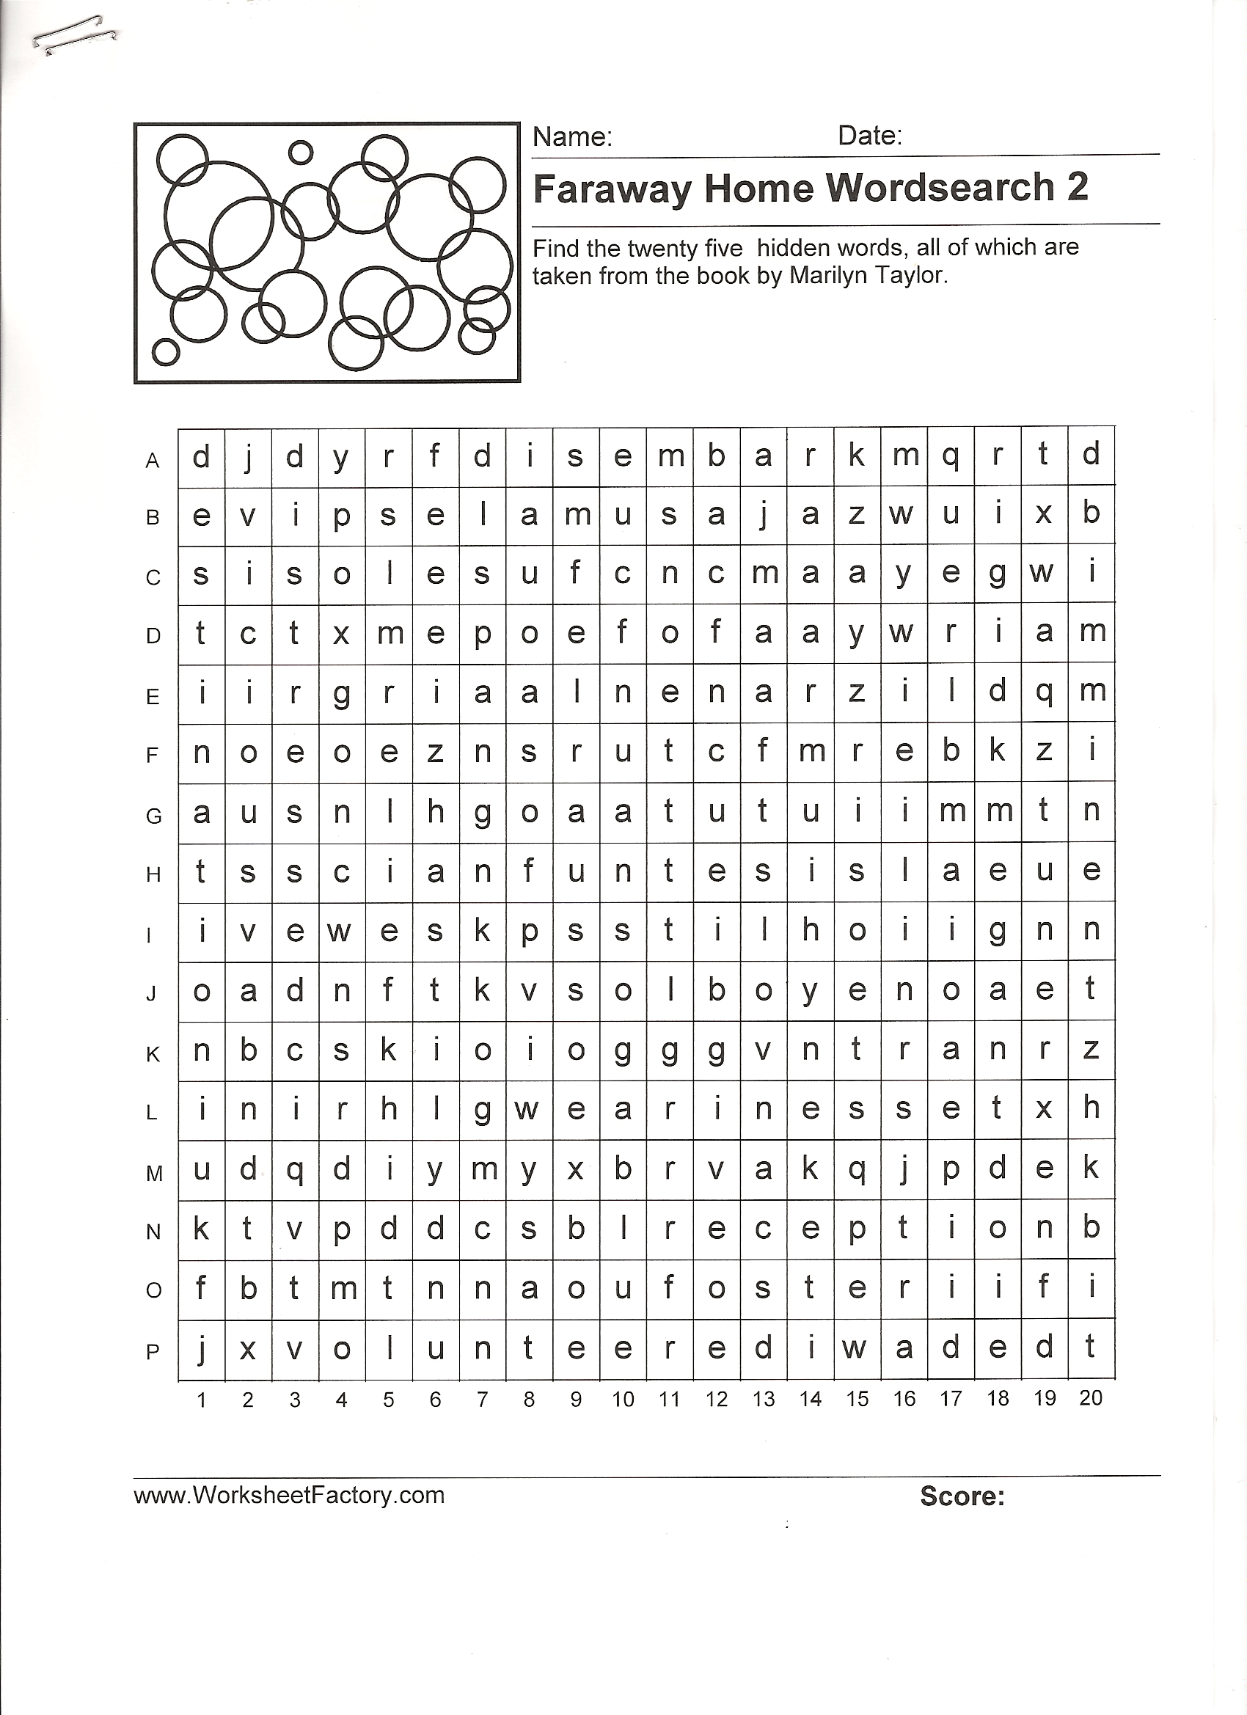
Find These 25 Hidden Words
in the Wordsearch

  - Rigid
  - Imminent
  - Distressed
  - Vicious
  - Destination
  - Disembark
  - Weariness
  - Reception
  - Foster
  - Volunteered
  - Waded
  - Acrid
  - Hastily
  - Relief
  - Ominous
  - Pleasant
  - Separation
  - Resolutely
  - Fluent
  - Ushered
  - Affectionate
  - Confusion
  - Unfamiliar
  - Carriage
  - Amazement

