We play with the toys

We wash our hands at the sink
We read books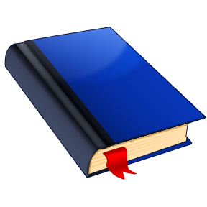 from the library
Look out the window
Open the door
Look at the television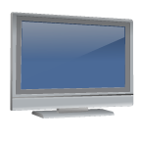
This is the whiteboard
Can I go to the toilet?

Turn off the lights

