Clothes
No. 23

Can you break the code and find the ten words about clothes?

1=i | 14=k  ❶ 19-18-8-5-19
2=f | 15=a
3=u | 16=t  ❷ 19-18-1-4-16  ❸ 19-8-20-14-19
4=r | 17=m
5=e | 18=h
6=l | 19=s  ❹ 19-14-1-4-16  ❺ 16-4-8-3-19-5-4-19
7=b | 20=c
8=o | 21=y
9=g | 22=v  ❻ 24-3-17-13-5-4
10=n | 23=w  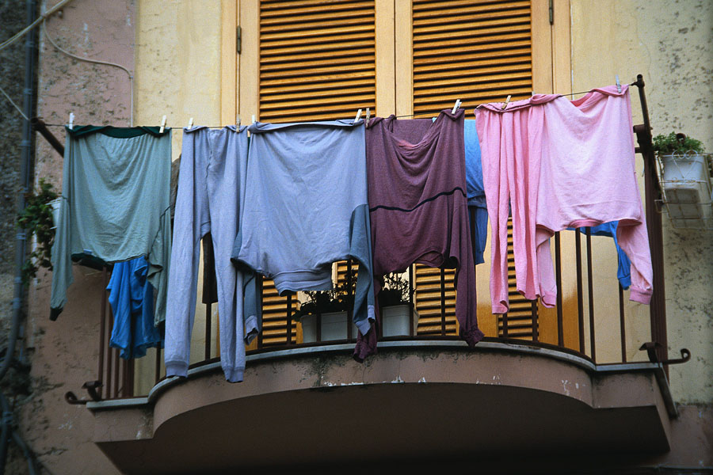
11=d | 24=j
12=z | 25=q
13=p | 26=x

❼ 20-8-15-16
❽ 18-15-16
❾ 9-6-8-22-5-19
❿ 16-4-15-20-14-19-3-1-16
Put each word into a sentence and underline the word in the sentence.

