Digital Cameras
A digital camera works in the same way that the older cameras worked in that you click a button to take a picture. However, the greatest difference is that you do not need to use a film for a digital camera. Instead, the photos are stored electronically on a small removable memory card inside the camera. The type of memory card used depends on the make of the camera but they are usually fairly standard. The most common ones are Smart Media cards and Compact Flash cards. These come in a variety of memory size from 32MB up to 2GB, but the memory capability is gradually increasing each year. Some cameras may have a built-in memory and photos can be saved to that memory.

1. Taking a Photo
Switch the camera on to “Take Photo” mode. There is usually a function on the camera that will allow you to zoom closer into a subject or zoom further away from a subject. There may be an automatic flash function on the camera or you may need to manually switch on the flash to take photos in darker surroundings.

Most cameras will allow you to view the photo you are about to take by displaying it on an LCD (Liquid Crystal Display) screen located on the rear of the camera. Other digital cameras may allow you to view the photo you are about to take by looking through a viewfinder. Most cameras will allow you to view the photo you have taken in the LCD screen and then you have the option to save or delete that photo.

2. Transferring the Images to the Computer

- Automatic Transfer
Most digital cameras will allow you to transfer the images on the memory card to the computer by using a USB (Universal Serial Bus) cable which connects the camera to the computer. When both are connected via the USB cable, turn the camera on and switch it to “Play” mode. If the software that came with the camera is loaded onto the PC that you are working on, the photographs should automatically load onto the computer by following the on-screen commands.

- Using Camera and Scanner Wizard
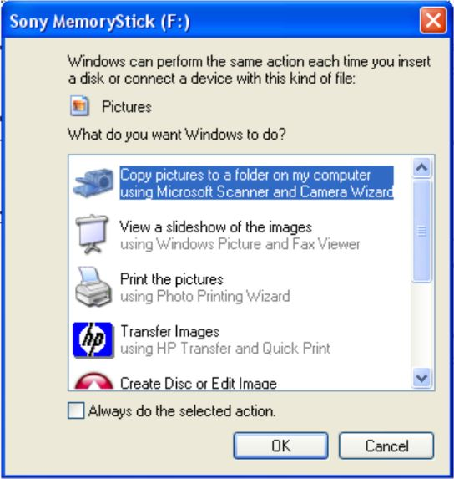
If the camera software is not loaded onto the computer, Windows may automatically recognise that you want to transfer files to the computer and the following window may appear. Select the option that says “Copy pictures to a folder on my computer using Microsoft Scanner and Camera Wizard” and click “OK”.

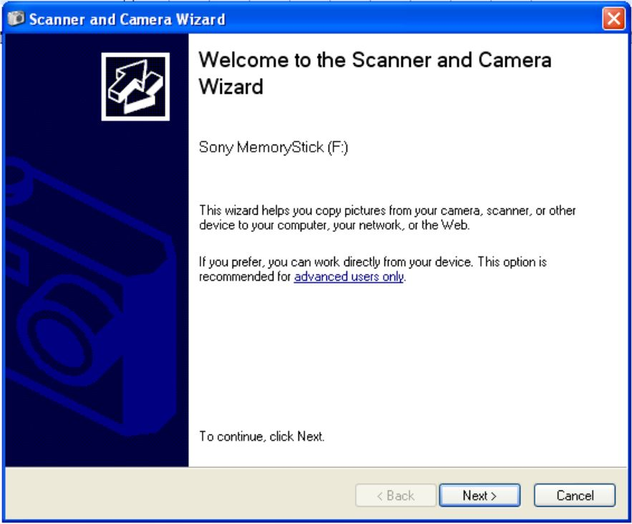
When the Scanner and Camera Wizard opens, click “Next”.

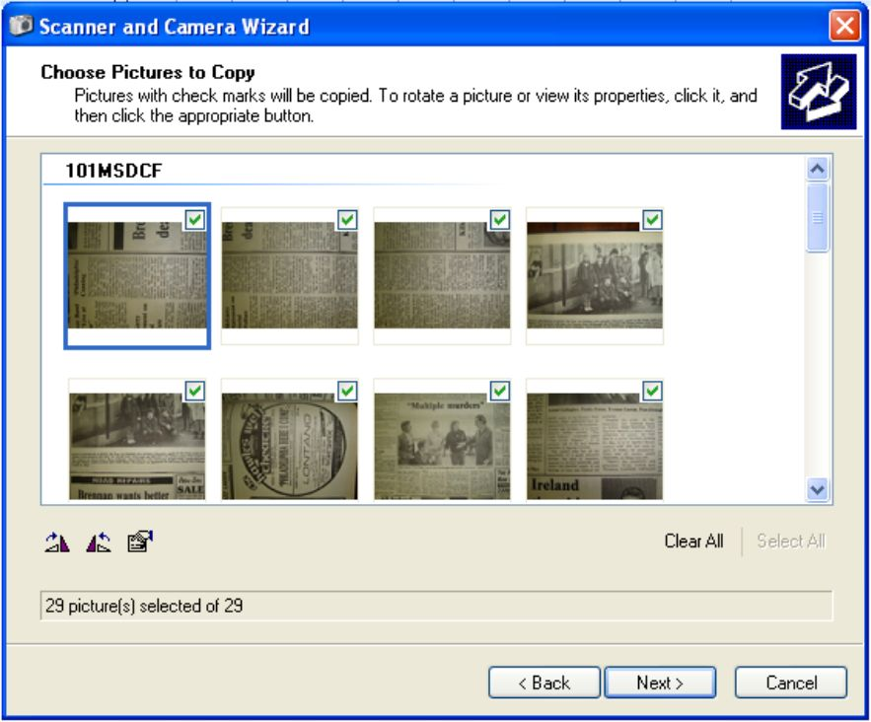
A window opens that shows thumbnails (miniature versions) of the photographs that are on the camera memory card. There is a green tick (√) automatically placed beside each photo. This means that every photo has been automatically “selected” to be transferred to the computer. If there are photos that you do not wish to transfer to the computer, untick them (by clicking the green tick) in this window.

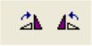
In the bottom left hand corner of this window, you can also choose to rotate any of the images on the memory card. If, for example, you have taken a photograph in portrait mode, this will need to be rotated 90º. To do this, select the photo by clicking it and then clicking one of these rotate icons on the bottom left of the window.

Near the bottom of this window, you will be informed how many of the photographs on the memory card you are proposing to transfer to the computer. When you have finished making any alterations in this window, click “Next”.

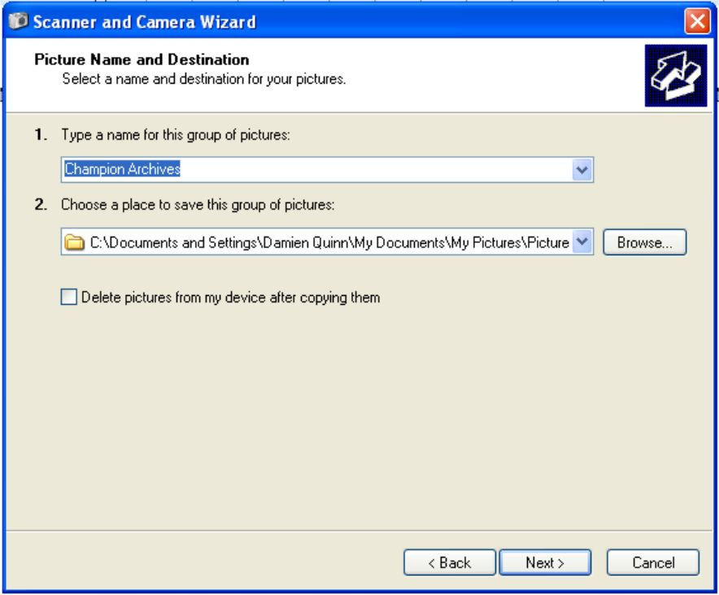
The “Picture Name and Destination” window now opens. In No. 1, type a name you wish to give this group of photos.

In No. 2, you are asked to choose a place on your computer in which to save all of the photos. You can leave the automatic selection, or you can decide to save the photos somewhere else by clicking the “Browse” button. The following window opens:

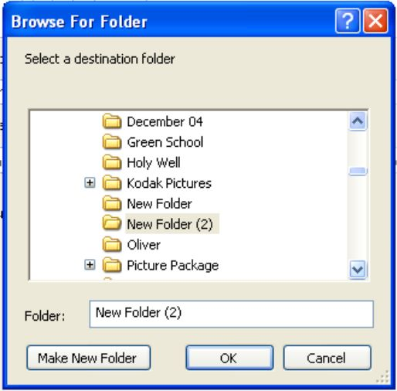
You are probably better to save your photos in the “My Pictures” folder in “My Documents”. Using the scroll bar on the right, scroll down until you find “My Pictures” and single click it turning it blue.

Click the “Make New Folder” button in the bottom left of the window. This creates a new folder in “My Pictures” called “New Folder” which should be coloured blue. While it is highlighted blue, type in a new name for the folder and click “OK”. This should now bring you back to the previous window.

Before you leave this window, you can choose to delete all the photos on the memory card of your camera by ticking (√) the box beside “Delete pictures from my device after copying them” which is in the centre of the window. Click “Next” and the following window appears:

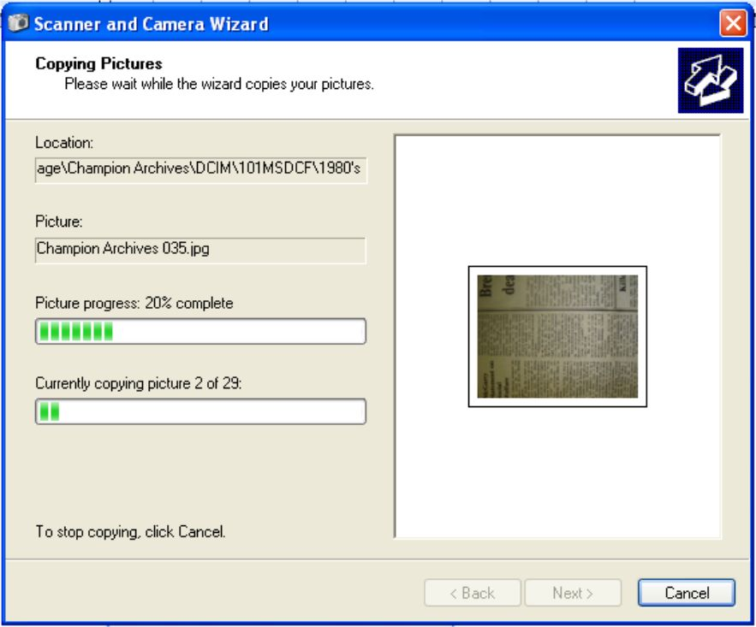
This window shows the progress of the transferring of the photos to the folder in “My Pictures” that you have just created. It transfers the photos one by one. Green bars move across the screen to show the transferring progress of each individual photo as well as the overall transfer job.

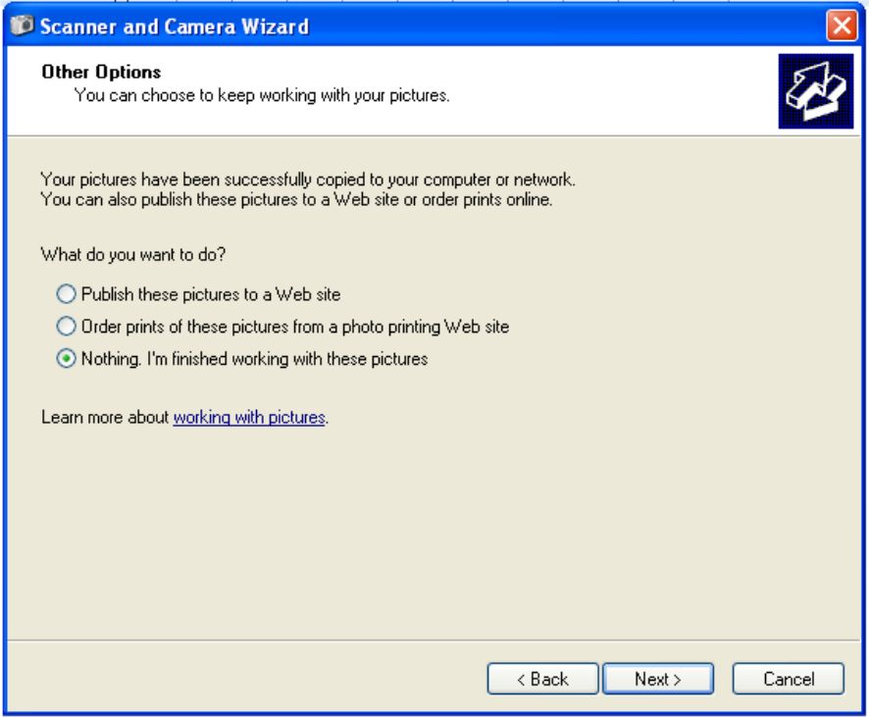
When all of the photos have been transferred, another window opens with “Nothing, I’m finished with these pictures” already selected. Click the “Next” button.

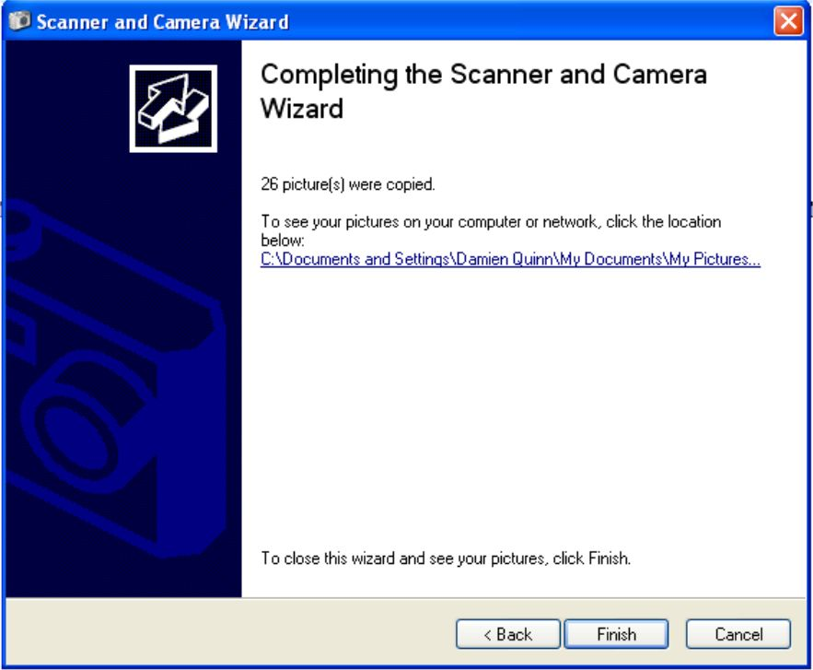
The final window appears informing you how many photographs were transferred and in what location they were stored. Click “Finish”.

A new window should open showing the new folder you created with all of the transferred photographs in the folder.

- Manual Transfer
If the camera software is not loaded onto the computer and the Windows Scanner and Camera Wizard did not start, the photos can be transferred manually.

You firstly need to create a folder to transfer your photos to. Go to “My Documents” and open up the “My Pictures” folder. In any white space in the folder, right click, select “New” and select “Folder”. This creates the new folder which is automatically called “New Folder”. This should be coloured blue. While the folder name is selected (coloured blue), type in the name you wish to call the folder and press “Enter” or “Return”.


If, when you created the new folder, you clicked outside the folder by mistake leaving it with the name “New Folder”, this can always be changed. To do this, right click the folder and select “Rename”. This highlights the folder name and you can now type in the new name you wish to call the folder. Double click the new folder to open it. When it opens, the folder should be empty because you have only just created it. Minimise the new folder by clicking the minimise icon in the top right hand corner of the window (the first of the three icons in the corner).

Next, click “Start”, and “My Computer”. Double click the removable drive icon representing your digital camera (this may be the “E”, “F” “G” or “H” drive). Open the folder in this drive containing the photographs on the digital camera memory card. Go to the top of the window, click “Edit” and, from the drop down menu, choose “Select All”. This highlights all of the photographs in the folder (they should all be surrounded by a blue box). With all of the photos still selected, click “Edit” and choose “Copy” from the drop down menu. This makes a copy of all of the selected photographs to an invisible clipboard on your computer. You can shut down this window by clicking the red “X” in the top right hand corner of the screen.

Re-open or maximise the folder that you previously minimised. This folder should be open but minimised on the toolbar at the bottom of the screen. It can be maximised by simply clicking it. Click “Edit” and choose “Paste” and this pastes all of the photographs from the clipboard into this new folder that you created.

Alternatively, you can open up the drive of the camera memory card and select all the photographs as described above. Under “File and Folder Tasks” on the left of the window select “Copy the selected items” and the following window opens:

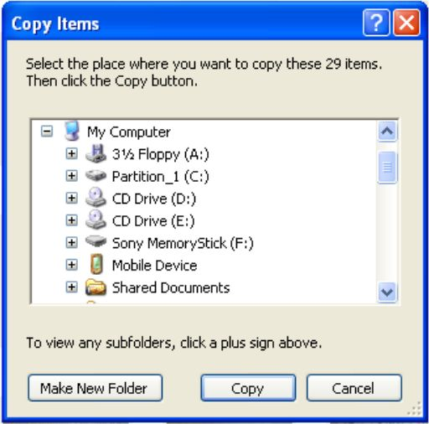
In the “Copy Items” window, select the folder you wish to copy the photographs to and click “Copy”. You can also create a new folder for the photos in this window as described earlier.

The above process described how to copy and paste a consecutive number of photos from the camera memory card to the computer. However, if you wish to copy a series of non-consecutive photos, the method of “selecting” the photos is slightly different. To select all the photos in the above process, you clicked “Edit” and “Select All”. To select random, non-consecutive photographs, just press and hold down the “Control” button (marked “Ctrl”) in the bottom left hand corner of your keyboard and click any photographs you wish to select/highlight. When you have selected all the photographs you wish to transfer, let go of the “Control” button and copy the photographs as before.

3. Viewing the photographs
To view all the photographs that you have transferred, firstly open the folder with all of the transferred photographs. Under “Picture Tasks” on the left of the screen select “View as Slide Show”. The photographs can then be viewed in full screen mode. Windows will automatically flick from one photograph to the next after about five seconds. If you want to view the photographs quicker, simply click the screen each time you wish to move on to the next photograph.



To end the slide show, move the cursor onto screen and click the red “X” that appears with other controls in the top right hand corner of the screen.

4. View Photographs on a TV Screen
If you wish to view photographs stored on your digital camera on a TV screen, locate a cable that may have come with your digital camera when you purchased it. The cable has a single “plug” on one end and on the other end it has two different colour “plugs”. (On my cable they are coloured yellow and black) Insert the single plug into your digital camera and insert the two plugs at the other end into your TV, matching the colours of the plugs to the colours of the sockets on the TV.

Turn on your digital camera, select the “Play” mode on the camera and you should be able to view the photographs on your TV screen. To scroll through the different photographs, use the arrows which are probably located on the back of your camera.

