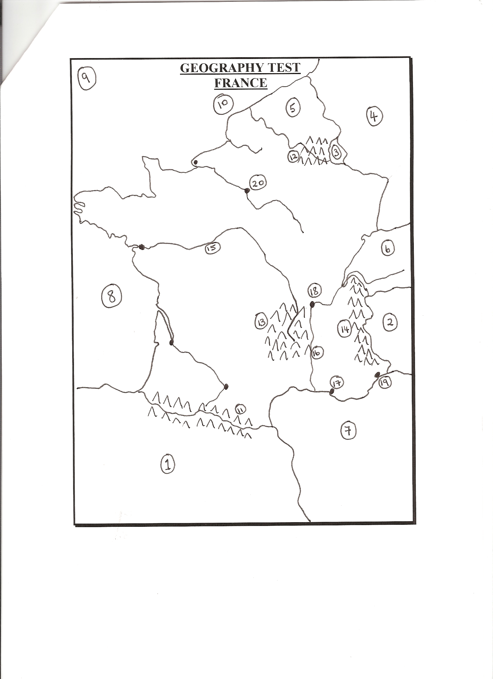

GEOGRAPHY TEST
FRANCE

Name the following:

Countries 1 - 6.
Seas 7 - 10.
Mountains 11 - 14.
Rivers 15 - 16.
Cities 17 - 20.

21. On what river is Paris built ?

22. What French city would you associate with a famous wine ?

23. Name France’s highest mountain.

24. In what mountain range is this highest mountain to be found ?

25. Name the following ferry routes to France:
Roslare to ___________.
Cork to _____________.
Dover to ____________.

26. Name three types of cars manufactured in France.

27. What is the name of the famous landmark to be found in Paris ?

28. In what year did the French Revolution take place ?

29. The main airport in Paris is named after a former French President. Who is he ?

30. What is the name of a famous cathedral in Paris ?

31. What is the name of a famous university in Paris ?

32. What is the name of the cycling race for which France is famous ?

33. Where is the World Cup in soccer to be held in 1998 ?

34. Who is the current French President ?

35. What is the name of the underground train system in Paris ?

36. What is the name of the supersonic jet built by French and British engineers ?

37. What letter would you find on a car which came from France ?

GEOGRAPHY TEST
FRANCE - ANSWERS

1. Spain 11. Pyrenees
2. Italy 12. Ardennes
3. Luxembourg 13. Masif Central
4. Germany 14. Alps

5. Belgium 15. Loire
6. Switzerland 16. Rhone

7. Mediterranean 17. Marseilles
8. Bay of Biscay 18. Lyons
9. Atlantic Ocean 19. Nice
10. English Channel 20. Paris

21. Seine.
22. Bordeaux.
23. Mount Blanc.
24. The Alps.
25. Rosslare to Le Havre
Cork to Roscoff
Dover to Calais.
26. Peugeot, Renault, Citroen.
27. The Eiffel Tower.
28. 1789.
29. Charles de Gaulle.
30. Notre Dame.
31. The Sorbonne.
32. The Tour de France.
33. France.
34. Jacques Chirac.
35. The Metro.
36. The Concorde.
37. F.

