Microsoft Word
Creating a Newspaper Format
The Microsoft Word software programme can easily be used to create the format of a newspaper by making use of the columns feature in MS Word.

1. Open the Programme
Open MS Word. There are three main ways of doing this.
- If you have recently been working on an MS Word document, you can open Word by clicking Start followed by MS Word which should be in the box above the Start button.
- If you have an MS Word shortcut icon on your desktop, just double click this and a blank MS Word document will open.
- The third way to open MS Word is to click Start, All Programmes, (Microsoft Office), Microsoft Word.

2. Set Up the Newspaper Format
Start by typing in the name for the newspaper eg. “The Ransboro Times”. Select this text and centre it into the middle of the page. Change the font style, size and colour by using the icons on the toolbar at the top of the window.

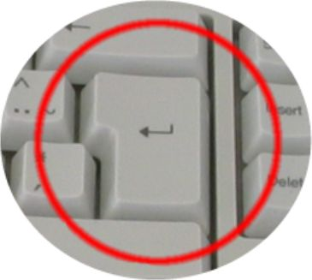
Make sure the newspaper name spans the width of the page and underline it. Click the return/enter button on the right hand side of the keyboard which brings the cursor onto the next line.

At the top of the screen click “Insert” and “Break” and the following window opens:

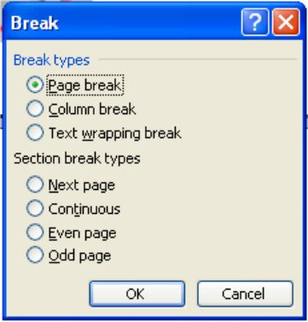
Under the “Section break types” select the “Continuous” option and click “OK”.

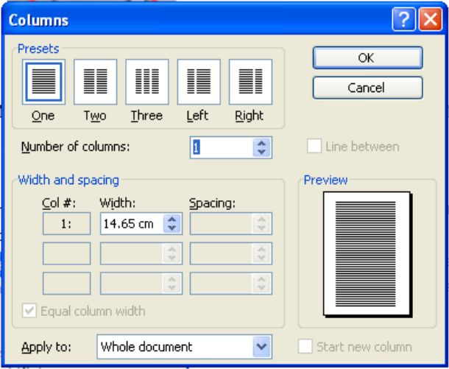
Next Click “Format” and “Columns” at the top of the screen and the following window appears:

Under the “Presets” selections click the icon that says “Three” underneath it. Tick the empty box beside “Line between” and a green tick will appear in the box. (This will insert a vertical line between the columns of text on the page) Click “OK”.

3. Insert the Text
Type in the text that you wish to appear in newspaper format. As you type, you will notice that the text only spans about one third of the width of the page. This is the first column in the newspaper. When you get to the end of the first column, the text will automatically begin in the second column and the vertical line will appear between the first and second columns. The same process will occur for the third column. When you get to the end of the third column, the text will automatically commence onto the first column in a new page.

4. Format the Text
Select all the text to be formatted by left clicking at the beginning and dragging the cursor to the end of the text. Use the toolbar at the top of the screen to format the selected text. Change the text font, size and colour; justify the text across the column (This makes the text have a straight line on both the left and right side of the column).

5. Format the First Paragraph
Select the opening paragraph of the newspaper story and make it bold by clicking the “B” button on the toolbar.

To insert a large dropped capital letter at the start of the newspaper article, click “Format” and “Drop Cap” at the top of the screen and the following window appears:

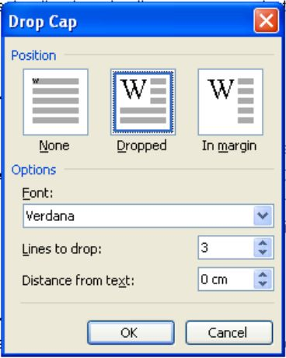
Click the middle icon named “Dropped”. You now have the option to change the font style of the dropped capital as well as the number of lines you wish the capital to be dropped and the distance you wish the dropped capital to be from the text. When you have made your selections, click “OK”.

6. Inserting Images
As with any other MS Word document, pictures/photographs/images can be inserted into the newspaper by clicking “Insert” and “Picture” at the top of the screen. You then have to decide whether to insert Clip Art, a picture/photograph from a file on your computer or some Word Art. The image may need to be resized to fit into the newspaper format.

