Printing Photographs
In order to print a series of photographs, you firstly need to open the folder containing the photographs. If you wish to print all of the photographs in the folder, go to the top of the window, click “Edit” and, from the drop down menu, choose “Select All”. This highlights all of the photographs in the folder (they should all be surrounded by a blue box).

If you wish to print a series of non-consecutive photos, the method of “selecting” the photos is slightly different. To select random, non-consecutive photographs, just press and hold down the “Control” button (marked “Ctrl”) in the bottom left hand corner of your keyboard and click any photographs you wish to select/highlight. When you have selected all the photographs you wish to print, let go of the “Control” button and your selected photographs should be surrounded by a blue box.

Under the “Picture Tasks” section on the left of the screen choose the “Print Selected Pictures” option and the Photo Printing Wizard opens in a new window. Click “Next”. Another window opens that shows thumbnails (miniature versions) of the photographs which you have selected to be printed. There is a green tick (√) beside each photo which means these are the photos “selected” to be printed. If there are photos here that you do not wish to print, untick them (by clicking the green tick) in this window. Click “Next”. The next window asks you to select a printer to send your photos to for printing. When you have selected your printer, click “Next” and the following “Layout Selection” window appears:

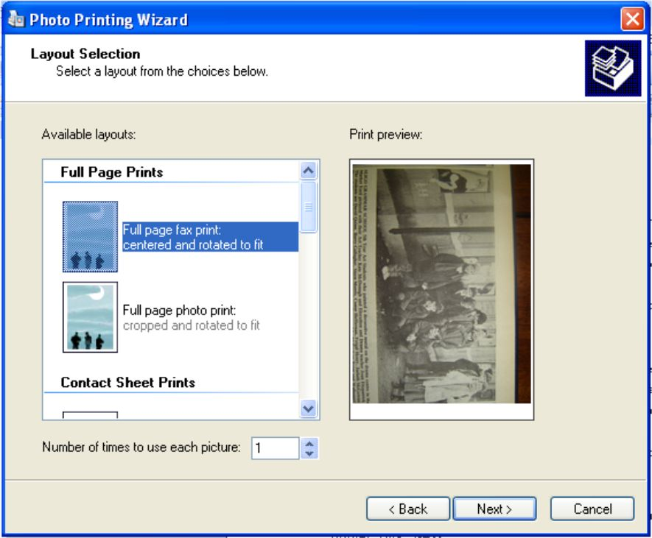
On the left hand side of this window are your options on how you want your selected photographs to be printed. For example, you can choose to have each photograph printed on full sheets of A4; you can choose to print a contact sheet with up to 35 thumbnails of your photographs on a single sheet of A4; you can choose to have two, three four or nine photographs printed per page of A4. To make a selection, you just need to click an option on the left of the window. When you make your selection on the left of the window, a preview of what the photographs will look like when printed on the page appears on the right of the window. You can change your mind at any stage while in this window as nothing has been sent to the printer as yet. At the bottom left of this window, you can also choose how many times to use each picture of your selection. Click “Next” and the photographs are sent to the printer for printing. When the final window appears, click “Finish”.

