Windows Sound Recorder
The Windows Sound Recorder is a very simple piece of software, a free utility that comes with Windows. It can be used to record voices, music and sound. These sound files can then be added to other pieces of software eg. Powerpoint. They can also be added to still photos to create a Sound Story in Windows Movie Maker. They can also be added to websites.

1. Open the Sound Recorder
To open the Sound Recorder click the following:
Start All Programmes Accessories Entertainment Sound Recorder
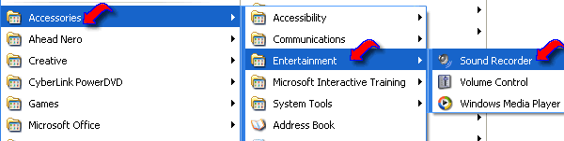

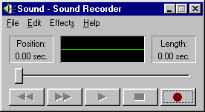
The following window will open:

The controls on the Sound Recorder are quite easy to understand. They are the standard controls that can be found on most CD players like Rewind, Fast Forward, Play, Stop, Record.
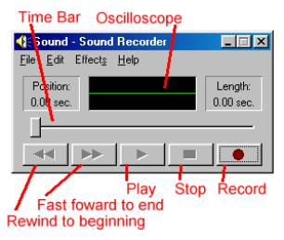
- In the centre of the window is a flat, green line called the Oscilloscope. As the sound plays or records, this green line oscillates to visually represent the sound.
- To the left is the Position indicator, represented in hundredths of a second.
- To the right is the Length indicator, showing the total duration of the sound file.
- Below these features is a Slide Bar indicator that shows where the sound file is playing, relative to its overall length. You can use the scroll bar to move through the sound file. The bar moves by either sliding it with the mouse or clicking on the right or left arrows.
- Finally, located below the Slide Bar, you’ll see the universal symbols (from left to right) for Rewind , Fast Forward , Play , Stop , and Record .

Because nothing has yet been recorded, the open Sound Recorder window is simply called “Sound” in the top blue toolbar. This will change after you name your sound recording.

2. Recording Sound
To record sound you will need an external microphone or an inbuilt microphone if your laptop/PC has one. If using an external microphone, plug it into the microphone socket on the laptop/PC. You are now ready to record.

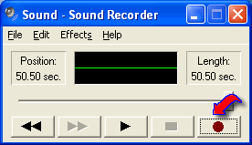

Holding the microphone close to the speaker’s mouth, click on the red “Record” button and begin to speak. As you record, you will notice that the Time Bar slider moves, the current position timer changes, and the oscilloscope changes in relation to the volume of the sound being recorded at that moment.

3. Saving the Sound File
When you have finished recording, click the “Stop” button . The recording will now need to be saved. To save the recording, click:
File Save As

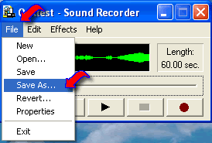

Choose where on your computer to save the file. Give the sound file a name. The sound file will then be automatically saved as a “.wav” file. The name you have given the file will appear in the blue toolbar at the top of the Sound Recorder window.

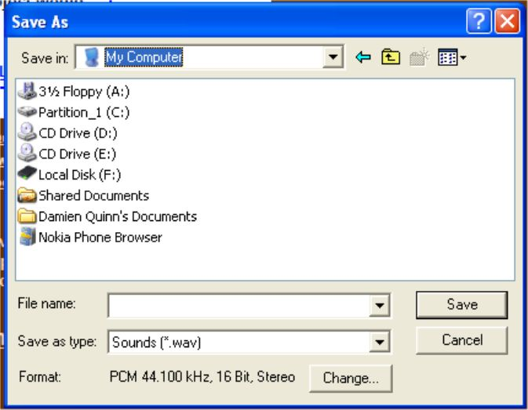

4. Playing the Sound File
After saving the sound file, you may play back the recording by simply clicking on the Play button . If you wish to play another saved sound file, click File and Open, locate the sound file on your computer and open it. Then click on the Play button. As the sound file is playing, the Time Slide Bar will slide to the right and the oscilloscope (green line) oscillates to visually represent the sound. You can use the scroll bar to move through the sound file. The bar moves by either sliding it with the mouse or clicking on the right or left arrows.

5. Adding Effects

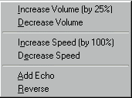
To give your sound file a little extra flavour, you can add special effects. These effects are available in the Effects menu and they manipulate the entire sound file. So if you only want a portion of the file to have a special effect, you’ll have to copy the sound file, cut it into portions, apply the effect a portion at a time and then combine them again.

The effects in Sound Recorder are:
- Increase Volume
This increases the volume by 25%. (However, you can select this option twice for a 50% increase, three times for a 75% increase, and so on.)
- Decrease Volume
This decreases the volume by 25%.
- Increase Speed
This doubles the rate of a sound’s playback.
- Decrease Speed
This slows the rate of a sound’s playback by 50%.
- Add Echo
This adds an audio reverb.
- Reverse
This reverses the sound so it can be played backward.

6. Increasing The Maximum Recording Time
Sound Recorder included with Windows has a default maximum time of 60 seconds of continuous recording. If you stop recording at any point before reaching the 60 second limit, you can then continue recording and have another 60 seconds of continuous time before Sound Recorder automatically stops. You can repeat this start-stop routine indefinitely if you need to record a long passage as one file.

7. Editing a File
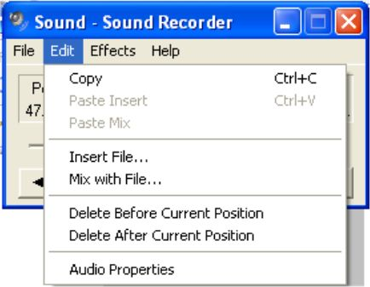
The editing tools are located in Sound Recorder’s Edit menu. After you edit a file, click Play to listen to your changes. If you like what you hear, save the file. (You’ll probably want to change the name.) If you don’t approve of the new sound, and you haven’t saved the file, choose Revert from the File menu to restore the file to its previous state.

The editing options are:
Insert File
This inserts an entire sound file anywhere in the current file. The file you wish to insert must also be in “.wav” format. An inserted file will increase the sound file’s length.
To insert a sound file into another sound file, you:
- Scroll to the desired location in the current sound file.
- Select “Insert File” from the Edit menu. The Insert File dialog box appears.
- Find the sound file on your computer that you wish to insert
- Click OK.
To listen, click Play. Remember, if you want to save the file, change the name. (You don’t want to write over the original sound file.)
Mix With File
This mixes a second file with the original file. The file you wish to mix must also be in “.wav” format. The sounds in the files will play simultaneously.
To mix a sound file with another sound file:
- Scroll to the desired position in the current sound file.
- Select “Mix With File” from the Edit menu. This brings up a dialog box.
- Find the sound file on your computer that you wish to insert
- Click OK.
To listen, click Play. Remember, if you want to save the file, change the name. (You don’t want to write over the original sound files.)
Delete Before Cursor Position
This deletes information/recorded sound from the beginning of the file to the current position in the file.

Delete After Current Position
This deletes information/recorded sound from the current position to the end of the file.

8. Volume Control
If you cannot hear the sound that you have recorded, you may have to check a number of things:
- Check that the speakers are plugged in at the power source and that they are switched on
- Check that the cable from the speakers is plugged into the correct socket on the laptop/PC
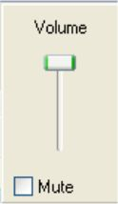
- Check that the system volume is not on mute or is not turned low. To check this, click the speaker on the toolbar in the bottom right hand corner of the desktop. The volume control window will appear. Make sure that the volume is turned up high.
- Check that the microphone has picked up the sound when recording. To check this, click:
Start Control Panel Sounds and Audio Devices

Click the “Audio” tab. Under “Sound Recording” click “Volume”. The following window should appear:

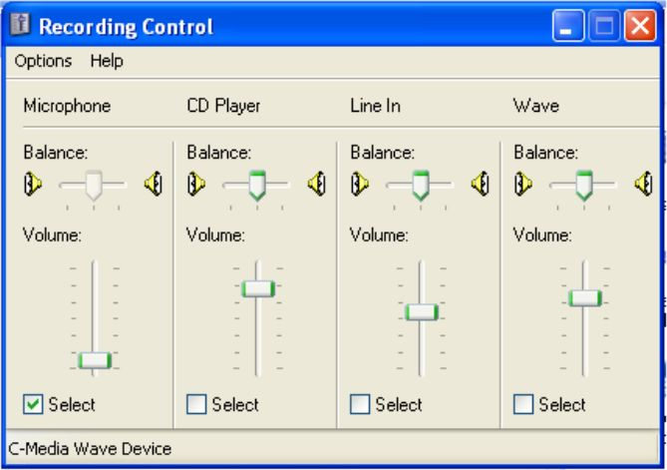
Make sure that the volume under the “Microphone” section is not turned down low. If it is too low, slide the cursor upwards. X out of this window and click OK.

