Name

Age
Sisters

Brothers

Favourite Food
Favourite Music
Favourite Sport
Favourite TV Programme

Favourite Animal

Favourite Colour
Friends
Favourite School Subject
My Reading Buddy is
Reading Buddies

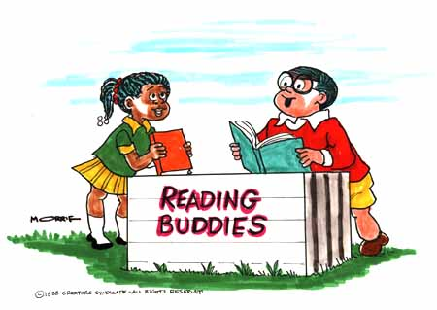
Signed:

________________________ (JB)

________________________ (SB)

Date:

________________________

