CREEPY CROSSWORD

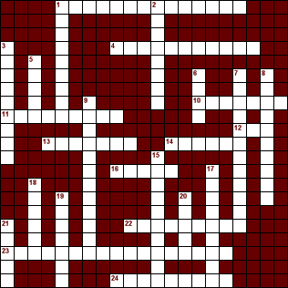

Across
1. Scooby and the gang's van
4. Movie character who appears when his name is called three times
10. Month Halloween takes place
11. Used by farmers to keep birds away
12. Ghost says this
13. Who likes to bite your neck?
14. Scooby Doo's best friend
16. Name of the hand in the Addam's Family
22. Cartoon that features Babs and Buster Bunny
23. The Olsen twins
24. Says "What's up Doc?"

Down
1. Teacher from the Magic School Bus cartoon series
2. Addam's Family mom
3. Addam's Family daughter named after a day of the week
5. Smart member in Scooby Doo's gang
6. Gremlins can't have this after midnight
7. Scooby's favorite snack
8. Movie where a group of kids search for buried gold
9. Kids say this on Halloween
15. Yakko, Wakko and Dot
17. Spooky time of the year
18. The friendliest ghost you know
19. Carve this for Halloween
20. Casts spells and flies on broom
21. Addam's Family dad

