Hallowe’en Sentences by ______________

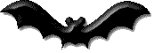 bat

The bat is _______________.

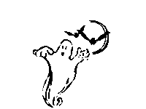ghost

The ghost is ________________.

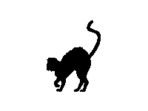cat

The cat is ___________.

 hat

The hat has a _______ star.
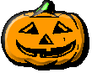pumpkin

The pumpkin is ___________.
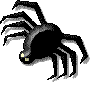spider
The spider lives in a _________.

witch
The witch is flying on her br___m.

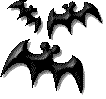three bats

I see _________ ________.

