Who were the Vikings?
The Viking people came from three countries of Scandinavia: Denmark, Norway and Sweden. They were also known as the Norse people. They were mostly farmers, but some worked as craftsmen or traders.

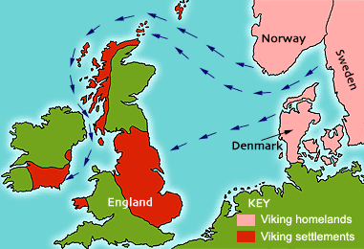
The name 'Viking' comes from my language which is called 'Old Norse'. It means 'a pirate raid'.


Many Vikings were great travellers and sailed all over Europe and the north Atlantic Ocean in their longships. Some went as fierce pirate raiders: they stole treasure and attacked local people. But most Vikings who sailed overseas were simply searching for better land for their farms.
The Viking Age began about 1,200 years ago in the 8th Century AD and lasted for 300 years.

Viking houses
Most people lived on farms. Their houses were built of wood, stone or blocks of turf, with thatched or turf roofs.

Men, women and children
Men worked on farms, or as craftsmen or traders. They handled boats for fishing or travelling. Sometimes a man had to fight to protect his family or to support his king or local chieftain.

Women did all the household jobs. They also helped on the farm, milked the cows and made cheese. They spun, wove and sewed all the family's clothes.
Children did not go to school. They helped their parents at work, and learned about history, religion and the law from stories. They became adults at the age of 15 or 16.

Food and feasting
Weddings, funerals and religious festivals were celebrated with a big feast for many guests. Some feasts lasted over a week!

Law and order
Most Viking countries were ruled by kings. Earls and chieftains were also powerful: some had their own armies and warships. Most farmers and craftsmen were ordinary freemen. There were also many slaves.

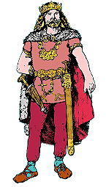
The king ruled over everyone.
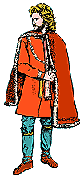 | 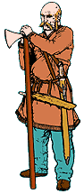 | 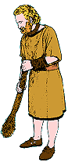
Earls and chieftains were also important leaders. | Most men were ordinary freemen. | Slaves were not free people. They belonged to a master.
A thing or assembly was a gathering of local freemen. They met together regularly in the open air to make and discuss laws and to decide punishments for criminals.
Many Viking families got caught up in violent blood-feuds. Any argument might end in a fight. If someone was killed, the dead man's family saw it as their right to take revenge. Blood-feuds sometimes ended by one side paying 'blood-money' as compensation.
A 'thing' is a big social occasion, where people got together to play sport, do business and arrange weddings.

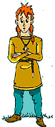

The Norse myths
When the Vikings first came to Britain, they had their own religion and worshipped many different gods. The stories they told about them are known as 'the Norse Myths'. They are mostly about contests between the gods and the giants.
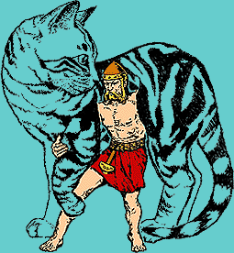
Thor, the god of thunder trying to prove his strength
to the Giant King by attempting to lift a giant cat.

Norse gods and goddesses
ODIN was the wise and mysterious 'All-Father', the ruler of the gods. He was the god of magic, poetry and war. He gave away one of his eyes in exchange for wisdom.
THOR was the most popular god. He ruled the skies, storms and thunder, and protected ordinary people. He had iron gloves, a magic belt and a hammer used as a weapon.
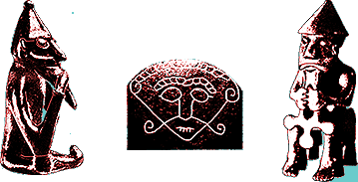
LOKI was the mischievous, dangerous trickster god.

The Vikings and Christianity
England, Scotland and Wales had been Christian countries for a long time. As the years went by, most Vikings living in Britain also became Christians. However, some continued to follow their old religion at the same time.
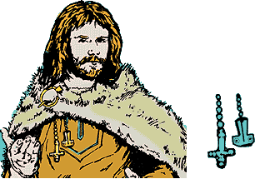
Many Viking lords founded new churches. They also put up stone crosses in churchyards all over Britain.

Trading
The Vikings traded all over Europe, as far east as Central Asia. They bought goods and materials such as silver, silk, spices, wine, jewellery, glass and pottery. In return, they sold items such as honey, tin, wheat, wool, wood, iron, fur, leather, fish and walrus ivory. Everywhere they went the Vikings bought and sold slaves.
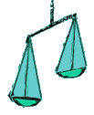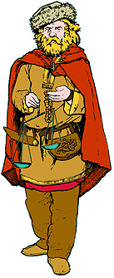
They paid for their goods using silver coins, or pieces of silver or jewellery. The value of the silver depended on its weight, so many traders carried round a set of scales.
Viking kings in England minted their own silver coins.
Viking ships
The Vikings were brilliant ship builders. Their ships were strong, lightweight and beautifully shaped to skim quickly through the water. Warships and raiding ships were designed to come right up on the beach so that men could jump out and start fighting straight away.
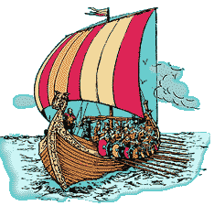
The ships were built of wood and made waterproof with tar from pine trees. The square sails were made of woven wool and were often brightly coloured. When the wind was wrong for sailing, they were rowed by teams of oarsmen. Many ships were decorated with carvings on their curved ends.
Viking sailors found their way by the sun, the stars, the direction of the wind, and by looking for familiar landmarks.
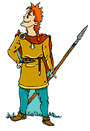

Discovering new lands
The Vikings were brave sailors and explorers. They thought nothing of taking their families on long, dangerous journeys across the sea. They discovered and settled in several remote countries that lay to the west of Britain in the north Atlantic Ocean: the Faeroe Islands, Iceland and Greenland.
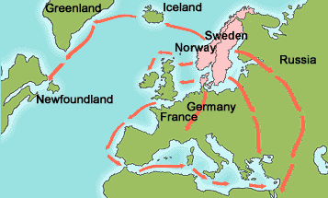
A Viking man called Bjarni Herjolfsson discovered America by accident in the year 985, when his ship was blown off course on the way to Greenland. A few years later, in 1001, Leif Eriksson 'the Lucky' sailed there to take a proper look at it. He was the first European to land in America.

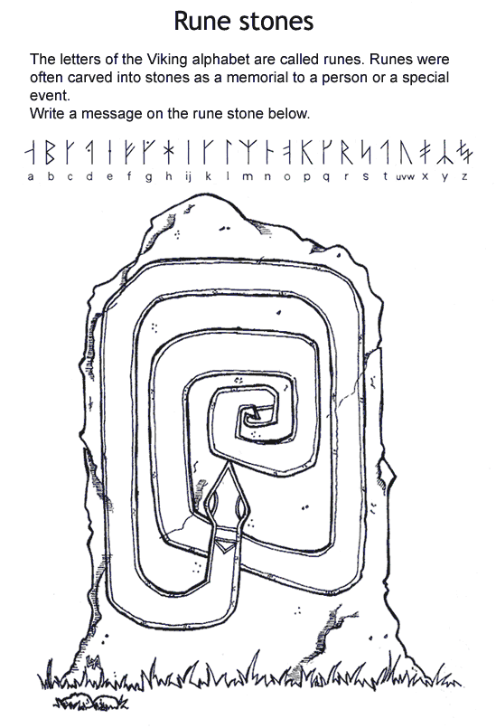

Blacksmith
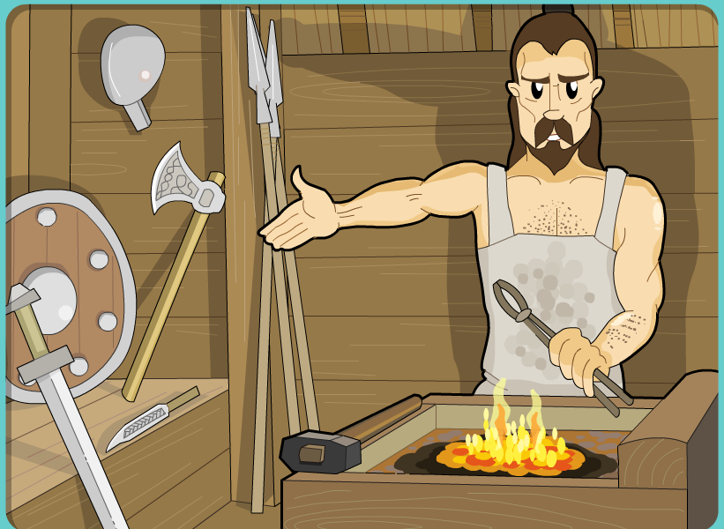

Leather worker
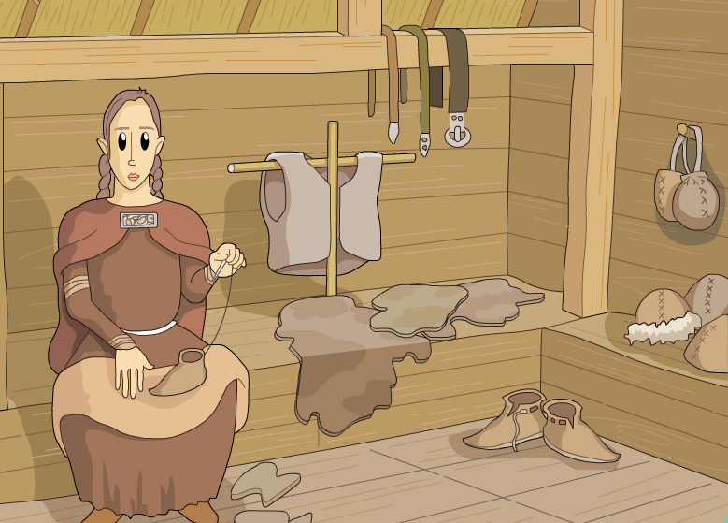
Woodcarver
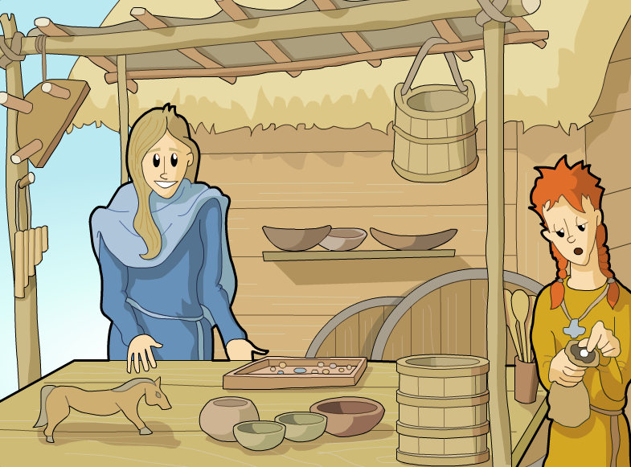

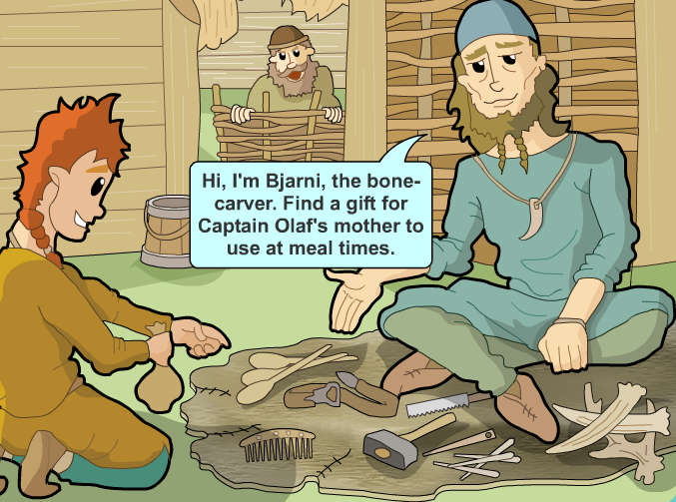

Jeweller
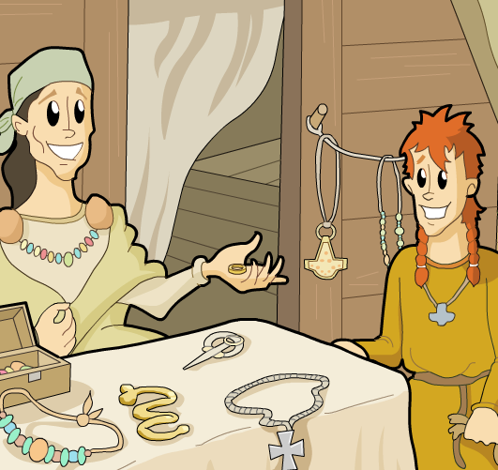
Viking warriors were adept at close-quarter combat and used all their weapons skilfully. Most Viking warriors could only afford the most basic weapons and armour.

Shields were the most common defence; they could deflect weapons, but were also used to thrust at the enemy. Spears also had a double purpose, but Vikings preferred to use them to stab rather than throw at the enemy.

Swords were crafted to be flexible and were more favoured than axes, the tool most frequently shown with Viking warriors. But swords, as well as chain mail and helmets, were expensive and used only by the few who could afford them.

On the Job
1. How would you become a Viking warrior?
Any Viking -- whether chieftains or farmers -- could organize a group of men for the purpose of raiding. Plundering expeditions such as the one in Lindisfarne were carried out by only small groups of men transported in three to six ships. Some of these foreign raids had royal approval, but for the most part these men acted on their own initiative for personal economic gain.
Viking warriors also served as volunteers in royal armies called lid in wars of conquest abroad or in neighboring lands. However, kings or local royal agents could gather men as part of levies for military campaigns at home.
2. What were the tactics of Viking armies?
Vikings did not have a professional standing army and their tactics and discipline were basic. They did not fight in organized formations and there was no formal weapons training; young Vikings learned how to use weapons through hunting. This is often the reason why Vikings were more successful in surprise attacks than in battling large, skilled armies.
The Vikings, however, still had tactics they used in battle. A frequent defense tactic was the shieldburg, or shield wall. Warriors lined up and overlapped their shields to protect themselves from spears. The warriors then threw their own shower of spears, followed with hand-to-hand combat. Vikings also formed what were known as svinfylking or a "boar formation" -- a wedge formation of 20 to 30 warriors to overcome their enemies.
3. How would a warrior become an army leader?
A warrior could become a leader by virtue of noble birth or military prowess. Viking warriors skilled in the use of all weapons -- swords, axes, and spears -- and those who proved themselves in battle could become commanders of small units. Frequently, however, Viking leadership positions were held by those of noble birth -- kings, earls, or clan chieftains. Viking kings commanded armies through their unit commanders of earls or chieftains.
4. When and how often would Viking warriors go on raids?
Viking raids began in the 790s and continued for decades. These surprise attacks were planned all throughout winter and were executed in the summer. The frequency of the raids ranged from once every few years to every year.

5. Could women Vikings become warriors?
Yes, there were women warriors in Viking society! Although for the most part, Viking women stayed home and ran the farm while their husbands were away, some women went along in Viking raids.

7. What happened to warriors who died in battle?
Viking warriors believed that Valkyries, warrior daughters of the principal Viking god Odin, presided over battles and chose those who were to die. Valkyries then brought the souls of the dead heroes back to Valhalla, Odin's banquet hall in the heavenly realm of Asgard. These warriors then became members of Odin's army, Einherjar who were then served beer and mead by the Valkyries in a feast. Chief among the Valkyries, and Odin's favorite was Brunhild, usually represented as riding through the air on horse, wearing a helmet and carrying a spear.

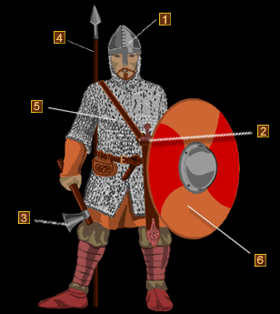

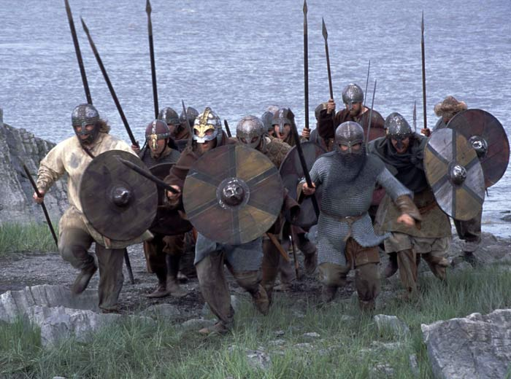

Land of the Vikings
During the 900s, the Vikings attacked the Irish monasteries across Ireland. The tall, fair-skinned Vikings came from Scandinavia. They were brutal fighters and robbers. They spread fear and destruction as they captured parts of France and Britain. They opened new trade routes, ruled cities in Russia, set up colonies in the North Atlantic, and explored North America. Norway, Sweden, and Denmark are Viking founded kingdoms.
The Land
The Viking homeland was Scandinavia.
It was a land of forests and long, rugged coastlines.
Jutland had natural harbors, and it was suitable for farming.
The rest of Scandinavia was rocky and had a short growing season.
People turned to the sea to make a living.
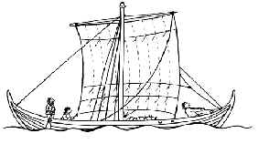
Ships
Viking ships were large and well suited for long voyages.
They were shallow enough to navigate rivers.
16 oars were on each side.
Shields were placed on the sides of the ships.
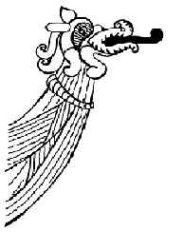
The bows were carved in the shape of a dragon's head.
Sails were square and red and yellow in color.
An awning in the front protected sailors from bad weather.
Ship Life
They slept in leather sleeping bags.
They cooked in bronze pots.
Vikings plotted their course by the position of stars.
Trade
They fished and traded in the North Atlantic.
Most of their traveling was in the spring after fields were planted.
In the winter they repaired boats and weapons.
Viking traders carried fish, furs, hides, and slaves to western Europe and the Mediterranean.
They brought back silk, wine, wheat, and silver.
Towns
Trade led to the growth of market towns.
Two main streets ran along the edge of the water.
Buyers and sellers set up booths.
Towns were protected by mounds of earth surrounded by wooden walls with towers.
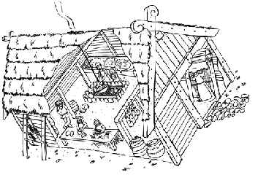
Villages
Most Vikings lived in villages.
Houses were made of logs or boards.
Slanted roofs were made of wood covered by sod.
Carved dragons decorated the roofs.
The houses had a small porch help up by carved pillars.
Jarls
There was no central government.
Military chiefs, jarls, ruled the people.
Some jarls were elected, and others inherited their job.
Some jarls conquered neighboring lands.
they were then kings.
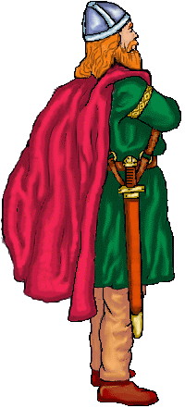
How Do We Know How The Vikings Dressed?
Finding clothing intact after being buried for hundreds of years is very unusual in archaeology. The fabrics people used in the past were made from wool and linen. Being organic, they quickly rotted. Very little is left for archaeologists to find and study.
In Scandinavia archaeologists have managed to find some clothing fragments, especially clothing belonging to Viking women. Since it was customary to bury Viking women in full traditional dress and with all of their personal belongings beside them, some pieces of fabric survived usually underneath metal jewelry such as the brooches.
This was not the case for the Viking men, however. When a Viking warrior died or was killed in battle, he was first dressed in full battle dress. The warrior was then cremated, destroying not only his body, but all of the clothing. His ashes and all of his weapons were then entombed in burial mounds. Some of these graves were outlined with stones that were carefully placed to resemble a Viking ship. Because they were so easily discovered by looters, many graves were robbed of their valuables over the ages. Only historical records, tapestries (large murals) and stone carvings have provided enough details to give us a complete picture of how Viking men dressed.
Viking Fashions For Men and Women
The clothing styles of Viking men and women depended on three things; 1. where in Scandinavia they lived, 2. their importance in a village and 3. how rich or poor they were. While all Vikings did not dress exactly alike, there were many similarities in the type and style of clothing worn. It is certain that as Vikings met each other, they exchanged ideas about many aspects of their lives, including clothing styles.
Viking men and women dressed more for purpose and comfort and less for fashion. The clothing worn suited the jobs they were doing. And, because the Scandinavian climate is cold, the clothes were a snug fit, not baggy as they were in warmer climates.
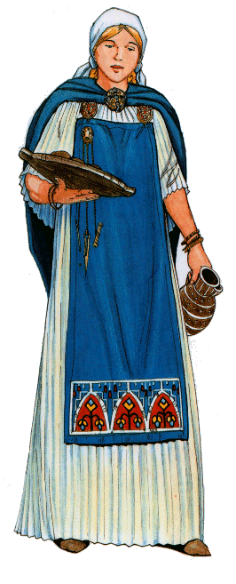
The Vikings loved bright colours. The linen and wool used to make their clothing was often brightly coloured using dyes extracted from various types of plants that grew naturally near their villages or in their vegetable gardens. Bright reds and blues came from berries. Green and yellow came from vegetables. Earthen pigments, like brown and black, came from ochres.
Making Clothes
Every Viking household had its own weaving machine. Linen and wool were spun into fibres which were woven into large pieces of fabric and finally fashioned into clothing. Because making clothes was very time-consuming, the cut of each piece was simple. Most pieces were pulled over the head. Necklines and armholes were made by not completely sewing the seam. Winter clothing, which consisted mainly of wools and animal hides, were cut and sewn the same way.
The Vikings often returned from their European raids with fine wool cloth and silk. Since these were very expensive, they were used mainly by wealthy Vikings like kings, earls and merchants.
Viking Female Clothing
The average Viking woman wore an ankle-length dress made of linen. She also wore a long apron over the dress to protect it from being soiled by her many household chores. She also carried some household items including a knife, a pair of scissors, fingernail cleaners and keys. These either hung from a belt worn around the waist or from a brooch attached to the apron about shoulder high. These items were carried this way because Viking clothing hod no pockets.
To complete her outerwear, a Viking women covered the dress and apron with a shawl. It was also fastened with a brooch at the base of her neck. The shawl hung down her back but could be brought forward for extra warmth, particularly when working outside. Her shoes were made of leather. For increased warmth, the fur was worn inside. Knee-length wool leggings completed the clothing.
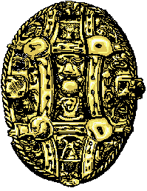
If a Viking woman was married, she wore a tight fitting head band or scarf that was knotted near the base of each ear. This type of garment is fashionable even today.
Viking girls wore smaller sized versions of their mothers' clothes.
The Brooch
The most common finds at many Viking archaeological excavations across Scandinavia are clasps, pins and brooches. Since the Vikings rarely used buttons or had no zippers, brooches were used to fasten clothing. They were first used by men to fasten a linen or fur cloak. Later, women used them as a fastener for dresses, aprons and shawls. It was only late in the Viking Age that brooches were considered a piece of jewelry.
Some of the brooches recovered from dig sites are hallow underneath and are often round or oval in shape. Others are shaped like animals. All are made of silver, bronze or iron. Needle brooches were also found but they are made of bone and were worn by poorer Viking women.
Brooches were used to fasten the back and front pieces of the dress and apron. When worn near each other, the brooches were often connected with a chain or string of glass beads. These beads often indicated wealth.
Jewelry
Vikings loved bright jewelry too. Viking artisans made exquisite pieces of jewelry from silver, bronze, gold and bone. They made brooches, finger rings, arm-rings, bracelets, pendants, ear rings and necklaces. The designs were based on everyday objects in their lives. Others pieces were based on designs observed in jewelry looted on raids in other parts of the world. Variations on designs seen in other parts of Europe were common in Viking jewelry. The richer the family, the more jewelry they owned. As it is today, jewelry was considered a status symbol.
The Vikings used silver to buy and sell anything they needed but could not make or grow themselves. Because most Viking jewelry was made of silver, brooches, rings and pendants were often used in place of coins. When payment for goods was required, a sliver of silver was cut from a piece of jewelry.

Viking Runes and Rune Stones
Like wrestling, swimming and fighting, writing was considered a special skill among the Vikings. The alphabet they used was invented by their ancient Scandinavian ancestors. According to legend, Odin, chief of the Norse gods, speared himself to a tree in an attempt to receive knowledge and learn the mysteries of the runes. He then passed this knowledge to his people. Since the Vikimgs believed the runes were a gift from the mighty Odin, they treated them with respect and believed they possessed divine, magical powers.
The letters or runes more than likely came from the greek and latin alphabets and were changed slightly probably because of the limited writing materials available to the Vikings. They did not have paper and did not use parchment or paper-like material. Their history and culture was, until 1200 A.D. passed down through stories and poems.
The Viking alphabet is often called the futhork after the first six letters of the original alphabet of twenty-four letters. The alphabet was later reduced to sixteen runes. This made spelling difficult for the carvers because all of the sounds in the language could not be covered. It also made it difficult for translators who tried to understand their meaning.
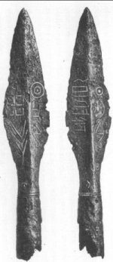
Viking runes weren't written with pen and ink on paper. Instead, runes were carved with a knife or chisel into stone and wood. To make carving into these surfaces easier, the runes were made using only straight lines. Words were formed by separating groups of runes with a period.
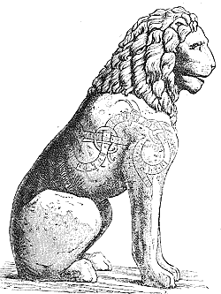
Runes weren't used to write stories. They were put to practical uses by ordinary Vikings. They were used for everyday writing such as labeling household items and personal belongings. They were also used by merchants to keep records of items bought and sold. Viking warriors decorated their swords and spears (like the ones pictured here) with runic characters too. The runes identified the owner of a weapon, and because the Vikings believed the runes were magical, they made the weapon stronger in battle. Viking believed that warriors who knew how to read and write runes could blunt enemies' weapons, break chains, cure illnesses, guard against witches and be protected in battle and on threatening seas.
Wherever the Vikings went, they left rune graffiti on rocks and buildings. Runes have been found carved into the altar railings of European cathedrals and stone statues like the one pictured here. In one way, it's lucky for us they did because some of what we know about them has come from these carvings.
The Vikings also used runes to inscribe memorial stones. Some of the inscriptions were tributes to fallen heros and loved ones. Others mocked a dishonest Viking who had betrayed friends and family. Nearly 3000 rune stones have been discovered across Scandinavia. Much smaller numbers have been unearthed in other parts of Europe.
Rune stones were usually large surface boulders with at least one naturally flat surface. The stones were often decorated with black, red, blue and white paint extracted from berries, garden plants and clay-like earth. The stones often depicted snakes, horses and ships along with the inscriptions. These stones and the sagas recorded by Viking poets called skalds, have helped archaeologists reconstruct some of what we know about the Vikings. Some rune stones are petroglyphs and give us a glimpse of what Viking life was like. What do your think the sign of the cross on this stone means?
Other runes were written on wooden slabs. Many of the slabs have rotted since the Viking Age and their stories have been forever lost. The memorial stones remain the single most common source of Viking runes still around today.
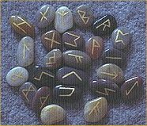
Viking rune characters were also inscribed on thumb-sized stones. They were placed in bags and removed one by one by Viking fortunetellers and magicians to tell the future, heal the sick, banish evil, or bless people, places, and things.

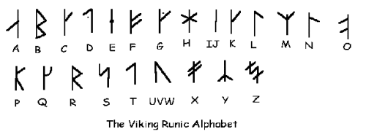
Here is the 24 character Viking runic alphabet arranged following our alphabetical order. It is no coincidence that some of them resemble our own alphabet. Our alphabet was influenced by the greek and latin alphabet too!

