Coloured Spider Webs
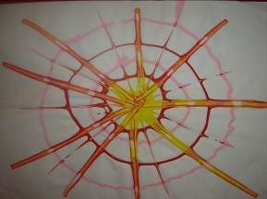

- This is a really quick and easy lesson to do and yet the children really enjoy the finished product.
- All paints in this lesson are poured directly from the bottle.
- Pour a blob of paint into the centre of the page.
- Using as many different colours as you wish, make circles of paint around the centre blob. Try to make sure you get a continuous line as you make the circles. Continue making circles of paint until you can’t fit any more.
- Using a lollipop stick or glue spreader, start in the centre blob and drag a line through all the circles of paint. The paints will make new colours as they mix when the lines are being made.
- Use the narrower side of the lollipop stick to make thinner lines between the thicker lines. Alternatively, use a cocktail stick or some other implement to make lines.
- Allow the picture to dry. This may take a couple of days for the thick circles of paint to dry

Variations
1. Use different types of paper.
2. Try using fingers instead of a lollipop stick to make the lines.
3. Make 4/5 groups of smaller circles around the page and end up with lots of smaller webs.

