Easter Silhouette #2
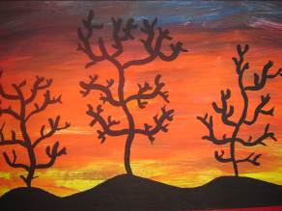
- With the eye, roughly split the page into quarters.
- Colour the top three quarters using primary colours in the order blue, red, yellow. Allow the colours to mix, thereby creating new colours.
- Using black, paint a silhouette of three hills, starting from the bottom of the picture as far as the background colours.
- Paint a black silhouette of a tree on each hill.
- Paint a black border on the page if desired.

