Lighthouse
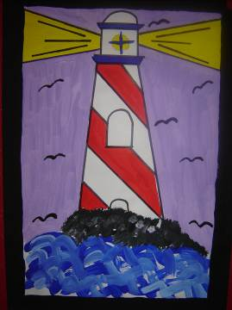

- Draw an outline of a lighthouse taking up two thirds of the page from the top. Draw in the light beams.
- Paint the lighthouse in any design/colour. Paint in some rock for the bed of the lighthouse.
- Paint in some waves in different shades of blue/white in the foreground. Paint in the light beams.
- Paint a background colour.
- Add in some birds to the sky.
- Lines can be traced over with thick black marker when the painting is dry.

