Paint ‘n Salt Picture
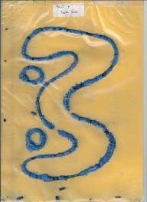

- Poster paint, table salt and stiff card are needed for this lesson. It’s quick and very easy to do.
- Explain the “Take a line for a walk” method for this lesson. Gently squeeze paint direct from the bottle onto the card. Try to squeeze a continuous line or some alternate pattern.
- When the paint has been squeezed onto the card, lay the card flat on the table/floor.
- Shake table salt all over the painted sections of the card, allowing the paint to soak up all the salt.
- Allow to dry. When dry shake off al the excess salt. The dried salt has now given a 3-D look to the pattern.
- Think of other things that could be shaken onto the paint instead of salt. Experiment with things like glitter, play sand. Rice Krispies etc.

