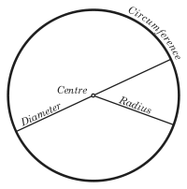
Parts of a circle
Diameter: a line which passes through the centre point of the circle from one point on the circumference to another.It is twice the size of the radius.
Radius: a line that begins at the centre point and touches off a point on the circumference.It is half the size of the diameter.
Centre point: the middle, or beginning point of a circle, where the compass marks the paper to begin drawing the circle.
Circumference: the outer boundaries, or perimeter, of a circle.
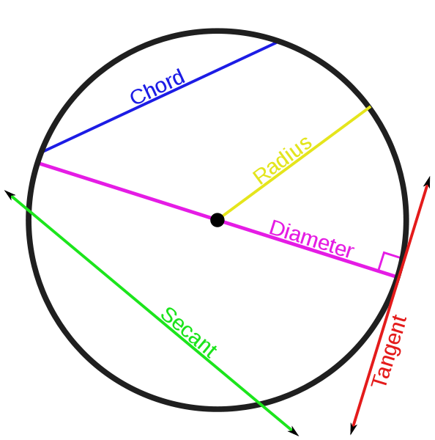Chord: is the term for any line which passes through a circle, beginning and ending within the circle.

A diameter is a chord which bisects the circle, cutting it into halves, forming two semi-circles.

The radius is a chord which cuts through the centre point of a circle to one part on the curved line of the circle.

A tangent is a straight line that touches off the circle at a single point.

A Secant is a line that contains a chord but it extends all the way through to outside of the circle.
PARTS OF A CIRCLE

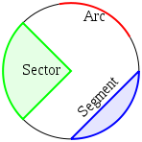

An arc: An arc of a circle is any curved part of the boundary line of the circle. It is any connected part of the circle’s perimeter.

A segment: A segment is a piece of a circle which has an arc as its outer line and a chord as its inner line. It does not necessarily run through the midpoint of the circle.

A sector: A sector is like a pizza slice. It is made up of two radii and the arc between the two radii. We have seen sectors before when dealing with fractions of a pie/ pizza.

Finding the circumference of a circle:

- Remember, the circumference is the outer boundary, the border or the perimeter of a circle.

- The ratio of a circle's circumference to its diameter is π (pi), a constant that takes the same value (approximately 3.141592654) for all circles.

- The formula for finding the circumference of a circle is:
- or

How do I this?
- Find the radius, then multiply it by 2
- Then multiply this answer by pi.

Finding the area of a circle:

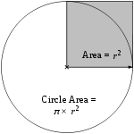
- Area of the circle = π × area of the shaded square
- The area enclosed by a circle is π multiplied by the radius squared:

How do I do this?
- First, find the radius.
- Then square it [multiply it by itself].
- Now, multiply this answer by pi [3.14]
- Finally, write your answers in units squared.

