Vase of Flowers

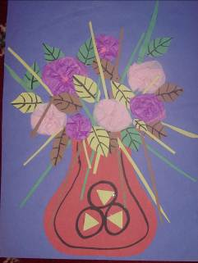

- Cut out a vase shape and stick it onto sugar paper. Decorate the vase. The vase should be about half the height of the sugar paper. (This could be a symmetrical vase by folding a sheet of paper and cutting out half a vase shape from the closed side of the paper)
- For the flowers, cut out lots of circles of tissue paper in different sizes and colours.
- Put two or three circles of tissue paper together. Fold the circles in half, and in half again. Twist a small bit of the point of the circles. Holding the twist, unravel the circles to reveal the flower petals. Experiment using different colour circles together.
- Glue the flowers in the top half of the picture, making sure they are at different heights and that some overlap the rim of the vase.
- Cut out and stick on leaves of different sizes and colours. (The leaves could be symmetrical by folding a sheet of paper and cutting out half a leaf shape from the closed side of the paper)
- Cut out and stick on long, thin pieces of green paper as grass and stems.

